**Lab Assignment – 4: Rest Web Service**

**In the Rest Web service, I have developed a web service which takes characters or string s as input and pops out with their ASCII value in Hexadecimal format. The screen shots of the Microsoft visual studio are shown below and also the Browser screenshots are shown below:**

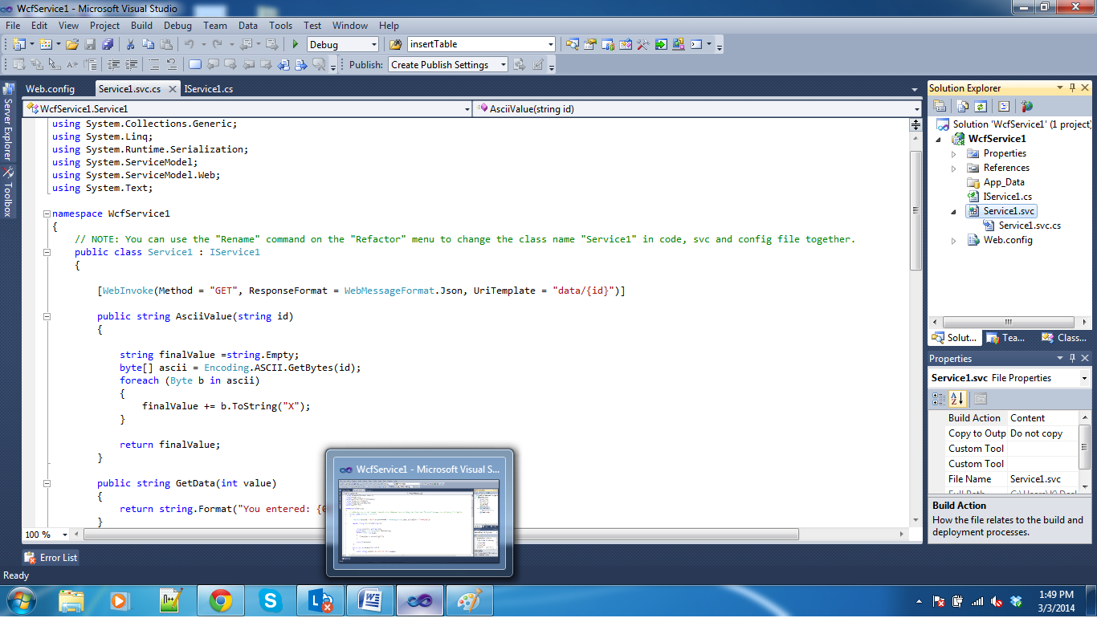

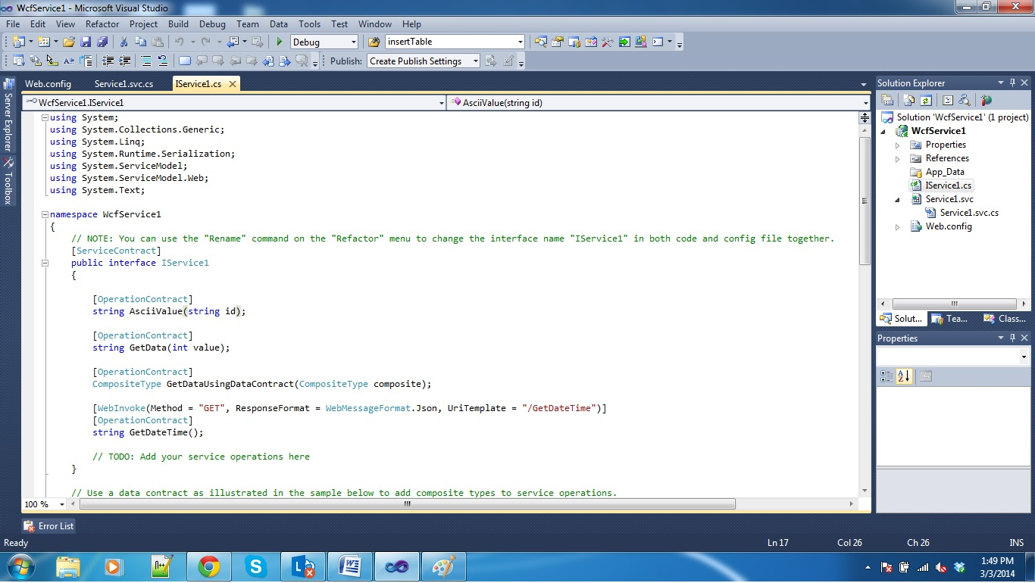

**The screenshot below shows the ASCII value of character “A”  
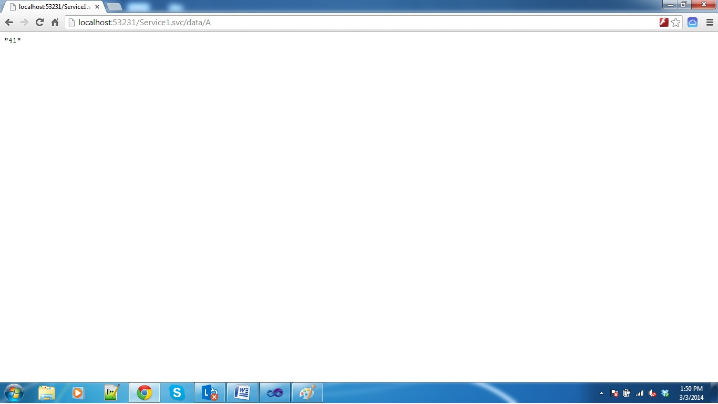**

**The Screenshot below shows the ASCII value of Character “K”**

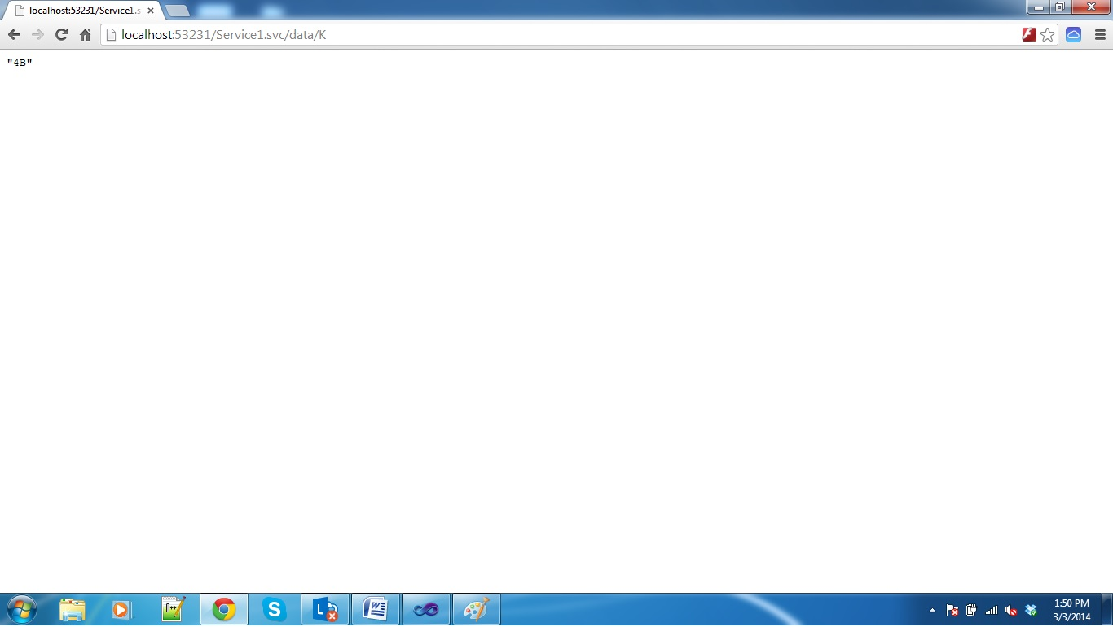

**The Screenshot below shows the ASCII character of the string “SUMANTH”**

